**Module 1 : Assignments**

**Q1. What is software? What is software engineering?**

1. Software is a set of instructions, code & data. That enables computers and digital devices to perform specific tasks and functions.
2. Soft eng. Is the systematic of principals, methods & tools to design , develop & maintain software system. Also ensuring they are reliable, efficient & meet users requirement.

**Q2. Explain types of software.**

1. System software: This is a types of computer programme that manages and controls the hardware and resources of a computer system.
2. Application software: Also called apps. One type of programme who’s specially designed for specific tasks like browsing, gaming etc.
3. Programming software: this is types of computer program that helps people to write and create another program. It provide some tools and make easier to edit and change code in program.
4. Education software: This is specially design for the learning and includes program for teaching various subjects and skills.

**Q3. What is SDLC? Explain each phase of SDLC**

1. **SDLC** [software development life cycles] is a structured process that software developers follow to create and maintain software application. Which is involves a series of steps from planning to desighning to coding, testing and deployment. To ensure that soft. Is developed efficiently and meets users crieteria. ( Just like a road map that guides the entire jurney of creating & managing soft. From start to finish)
2. **Planning** : In this phase where we Deeside what the soft. Should do who will use it and how it will be built. Setting the roadmap of entire project. Like a project scope, budget & schedule are determined.
3. **Analysis** : where you thoroughly examine and understand the requirements, needs, and constraints of a project. It involves gathering and assessing information to define what the software should accomplish and how it will function, laying the foundation for the development processs.
4. **Design** : In this phase, where we plan and create the detailed structure and layout of the software based on the analysis. It's like creating a blueprint for the software, specifying how it will look and function, before actual development begins.
5. **Implementation (coding**) : In this phase, developers write the actual code for the software, following the design specifications. This phase involves coding, unit testing, and code reviews to ensure that the software functions as intended.
6. **Testing** : In this phase, soft. Is systematically checked & evaluatedto ensure it works correctly and meet the defined requirements. It's like quality control to catch and fix any issues or bugs before the software is released to users.
7. **Deployment** : After successful testing, the software is deployed to a production environment. This may involve installation, configuration, data migration, and user training.
8. **Maintenance & Support** : Once the software is in production, it enters the maintenance phase. During this phase, ongoing updates, bug fixes, and enhancements are made to address issues and adapt to changing requirements. It's like taking care of the software to keep it running smoothly.

**Q4. What is DFD? Create a DFD diagram on Flipkart**

DFD stands for "Data Flow Diagram." It is a graphical representation used in software engineering and systems analysis to visualize the flow of data within a system or a process. DFDs are particularly useful for understanding how data is input, processed, and output in a system, and they are an essential tool in system design and documentation.

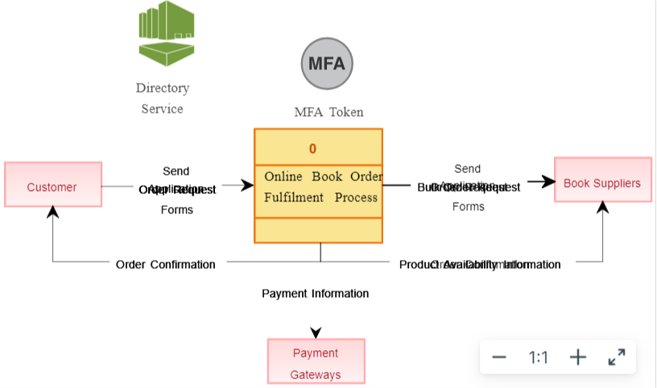 A Data Flow Diagram (DFD) for a simplified view of an online shopping website like Flipkart can be broken down into four main components: the user, the website, the database, and external entities. Here's a short and easy-to-understand DFD for Flipkart:

1. User (Customer):

Represents the person using the Flipkart website.

Initiates actions like searching for products, adding items to the cart, and making payments.

1. Flipkart Website:

Serves as the central platform for online shopping.

Manages user interactions and processes requests.

1. Database:

Stores product information, user profiles, order history, and transaction details.

Provides data to the website when needed.

1. External Entities:

Payment Gateway: Handles online payments securely.

Product Suppliers: Provides product information and availability.

Data Flow:

* The User interacts with the Website.
* The Website sends product search queries to the Database.
* The Database returns product information to the Website.
* The User adds products to the cart through the Website.
* When the User decides to make a purchase, the Website sends payment details to the Payment Gateway.
* The Payment Gateway processes the payment and informs the Website about the transaction status.
* The Website updates the Database with the order information.
* Product Suppliers provide product availability information to the Database.

This simple DFD illustrates how data flows between the user, the website, the database, and external entities like payment gateways and product suppliers within the Flipkart system.

**Q5. • What is Flow chart? Create a flowchart to make addition of two numbers**

A flowchart in information technology is a visual representation that uses symbols and arrows to illustrate the step-by-step sequence of a process, making it easier to understand and analyze.

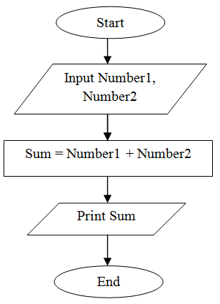

Flowcharts in IT can be categorized into several types, each serving a specific purpose. Here are some common types of flowcharts used in information technology:

Here is the some field related flow charts :

* **System Flowchart:** A system flowchart provides an overview of an entire information system, illustrating the input, processing, storage, and output components. It shows how data flows through the system, from the initial input to the final output, often including hardware and software components.
* **Program Flowchart:** Program flowcharts are used to represent the logical flow of instructions within a computer program or software application. They show the sequence of operations, decision points, loops, and the overall program structure.
* **Data Flow Diagram (DFD):** While not strictly a flowchart, a DFD is a diagram used in IT to represent the flow of data within a system. It shows processes, data stores, data flows, and external entities, making it a valuable tool for understanding data movement in systems.
* **Network Diagram:** Network diagrams, including network topology diagrams and network infrastructure flowcharts, illustrate the layout and connections of computer networks, including servers, routers, switches, and endpoints.
* **Algorithm Flowchart:** Algorithm flowcharts depict the steps and decision points in an algorithm or a specific problem-solving process. They are commonly used in programming to plan and design algorithms before coding.
* **Database Flowchart:** Database flowcharts represent the flow of data within a database system, including the retrieval, insertion, updating, and deletion of data records. They often include SQL queries and data manipulation operations.
* **Workflow Diagram:** Workflow diagrams are used to represent the step-by-step processes in business operations or IT systems. They are essential for documenting and optimizing business processes and automation.
* **Deployment Flowchart:** In the context of software development, deployment flowcharts show the process of releasing and deploying software updates or applications to production environments.
* **Troubleshooting Flowchart:** These flowcharts are used to systematically diagnose and resolve issues or problems in IT systems, providing a structured approach to problem-solving.
* **Security Flowchart:** Security flowcharts outline security protocols, access controls, and authentication procedures within an IT system, helping to ensure the security of data and resources.

**Q6. What is Use case Diagram? Create a use-case on bill payment on paytm.**

A use-case diagram is a visual representation in software engineering that shows how different actors (users or systems) interact with a system or software application to achieve specific goals or tasks.

Below is the Diagram:

